Report on Conduct of 10-Day Capacity Building Programme under Mission Yuva

Institution: Government Degree College, Frisal
Duration: 13 January 2025 to 25 January 2025
In compliance with the directions issued by the competent authority under Mission Yuva, Government Degree College (GDC), Frisal conducted a 10-day Capacity Building Programme from 13.12.2025 to 26.12.2025 for the identified beneficiaries.
A provisional list of 112 candidates was received from the District Employment and Counselling Centre (DECC) for the purpose of registration. On verification, it was observed that 82 candidates were already registered with other training centres, while 7 candidates declined participation. Accordingly, 23 candidates were registered at this institution. Out of the registered candidates, 11 candidates attended the programme regularly during the prescribed period.
The programme was coordinated by Dr. Mehraj Ahmad Sheikh, Assistant Professor, Department of Commerce, GDC Frisal, who also functioned as the Resource Person. Mr. Muzaffer Ahmad Rather provided necessary assistance with regard to candidate registration and facilitation during the conduct of the programme.
At the commencement of the programme, the registered candidates were briefed regarding the procedure for marking attendance on the designated portal. The programme commenced with a welcome address by the Programme Coordinator, followed by an orientation session highlighting the objectives and scope of Mission Yuva. The Mission Yuva Tarana was played in accordance with the prescribed protocol.
The training was imparted strictly as per the syllabus prescribed under Mission Yuva, and all required procedural formalities were duly completed. On completion of the programme, the attendance was verified, and the list of eligible candidates was forwarded to the District Employment and Counselling Centre (DECC) for approval. Upon approval by the competent authority, the certificates were generated and distributed among the eligible candidates.
The programme was concluded as per norms. This report is submitted for information and record, please.

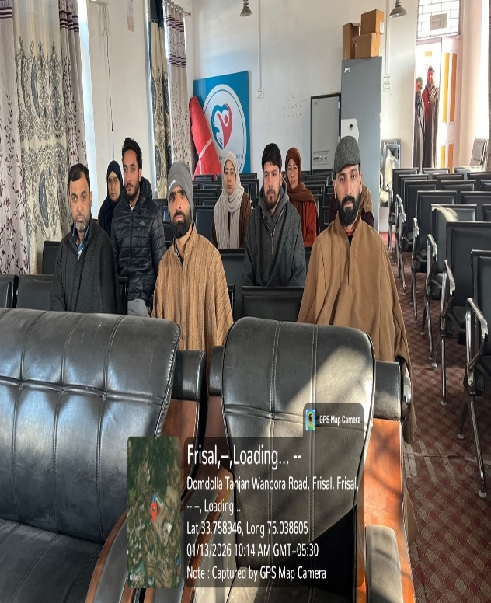 | 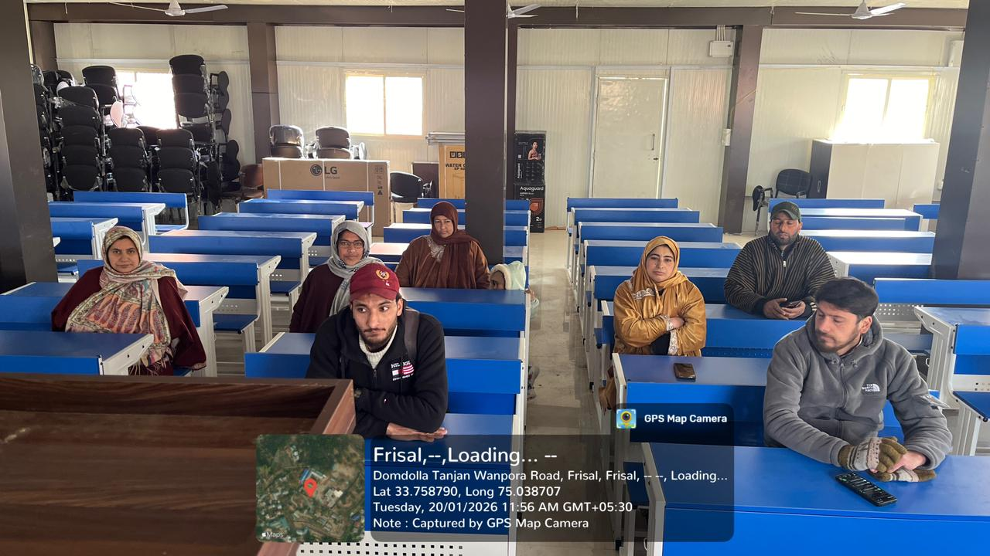

Copy to: Principal
1. IQAC Convenor GDC Frisal
2. In charge Website/FB for wide publicity
3. Office Record

